  - The dataset contains two target variables with different characteristics: stab, which is a continuous numerical variable representing the stability value, and stabf, which is a categorical variable indicating system stability status (stable or unstable). Due to the different nature of these targets, two different machine learning models were selected.
For the stab target, a Linear Regression model was implemented. This model is suitable because stab is a continuous variable, and regression models are designed to predict numerical outcomes. Linear Regression was chosen as a baseline model due to its simplicity, interpretability, and ability to capture linear relationships between the input features and the stability value. The model’s performance was evaluated using regression metrics such as Mean Absolute Error (MAE), Root Mean Squared Error (RMSE), and R² score. The trained model was deployed using MLflow, allowing it to be saved, tracked, and used to generate predictions on new data.
For the stabf target, a K-Nearest Neighbors (KNN) classifier was built. This model is appropriate because stabf is a binary categorical variable, making the task a classification problem. KNN was selected due to its effectiveness in capturing local patterns in numerical data and its suitability for problems with potentially non-linear decision boundaries. Since KNN is distance-based, feature scaling was applied using standardization before model training. Hyperparameter tuning was conducted by evaluating multiple values of k, and the optimal value was selected based on minimizing the mean classification error. Model performance was assessed using accuracy and F1-score to account for class imbalance. The classification model was also deployed using MLflow, enabling experiment tracking, model versioning, and reproducible predictions.

  - Regression Model (Predicting stab)
The Linear Regression model achieved an R² score of 0.64, indicating that approximately 64% of the variance in the stability value (stab) is explained by the input features. This suggests a moderate to good fit, considering the linear nature of the model and the complexity of electrical grid dynamics.
The Mean Absolute Error (MAE = 0.0176) and Root Mean Squared Error (RMSE = 0.0220) are relatively low, showing that the model’s predictions are generally close to the true stability values. The small difference between MAE and RMSE indicates that the model does not suffer from large outlier errors for in-distribution data.
Weaknesses:
Despite acceptable performance, Linear Regression assumes linear relationships and cannot capture non-linear interactions between system variables. Additionally, the model is sensitive to input values outside the training data distribution, which can lead to extreme predictions.

Possible Improvements:
Apply feature scaling and deploy the model as a pipeline to ensure robustness during deployment.
Introduce non-linear models such as Random Forest or Gradient Boosting to capture complex relationships.
Apply regularization techniques (Ridge or Lasso) to reduce sensitivity to extreme values and improve generalization.
Use feature engineering or interaction terms to enhance predictive power.
model could be trained using optimization-based methods such as Gradient Descent instead of the closed-form solution. This approach would be more scalable for larger datasets and could be extended to regularized or non-linear variants of regression.
Classification Model (Predicting stabf)
The KNN classifier achieved an Accuracy of 85.9%, indicating strong overall classification performance. The F1-score of 0.90 reflects a good balance between precision and recall, making the model reliable for stability classification.
The high Recall (98.5%) shows that the model is highly effective at identifying most unstable cases, which is particularly important in safety-critical systems such as electrical grids. However, the lower Precision (82.7%) suggests that some stable cases are misclassified as unstable.
Weaknesses:
KNN is sensitive to the choice of the hyperparameter k and relies heavily on distance calculations, making it sensitive to feature scaling. It may also become inefficient as dataset size increases.
Sensitive to noise and irrelevant features
Possible Improvements:
Apply cross-validation to select the optimal value of k.
Experiment with alternative classifiers such as Logistic Regression, SVM, or Random Forest.
Reduce dimensionality using PCA to improve distance-based learning.

Overall Evaluation
Both models demonstrate satisfactory performance for their respective tasks. The regression model provides reasonable numerical predictions of system stability, while the classification model performs strongly in distinguishing stable from unstable conditions. However, the identified weaknesses highlight opportunities for improvement through advanced modeling techniques and enhanced preprocessing strategies.

Exploratory Data Analysis (EDA)
Exploratory Data Analysis was conducted to understand the structure, quality, and characteristics of the electrical grid stability dataset before model development.
First, the dataset shape was examined to identify the number of observations and features. The dataset contains multiple numerical input features (tau1–tau4, p1–p4, g1–g4) and two target variables: stab (continuous) and stabf (categorical). The info() function confirmed that all features are numerical and that there are no missing values, indicating good data quality and eliminating the need for imputation.
Summary statistics were analyzed using describe(), which showed that the features have different ranges and scales. For example, the tau variables range approximately between 0.5 and 10, while the g variables range between 0.05 and 1. This difference in scale justified the use of feature scaling for distance-based models such as KNN.
The distribution of the continuous target variable stab was visualized using a histogram, which showed a continuous spread of values around zero with no extreme skewness. This supported the selection of a regression model for predicting stab.
For the categorical target stabf, class distribution analysis revealed a moderate class imbalance, with more samples labeled as unstable than stable. This imbalance was considered during model evaluation by using metrics such as precision, recall, F1-score, and confusion matrix rather than relying on accuracy alone.
Overall, the EDA phase confirmed that the dataset is clean, numerical, and suitable for both regression and classification tasks, while also highlighting the need for feature scaling and careful evaluation of classification performance.
B) Feature Scaling
Feature scaling was applied using standardization to transform all numerical features to a common scale with zero mean and unit variance. This step was necessary because the dataset contains features with significantly different ranges, such as tau, p, and g variables. Since the K-Nearest Neighbors algorithm relies on distance calculations, unscaled features with larger magnitudes would dominate the distance metric and bias the classification results. By applying feature scaling, all features contribute equally to the distance computation, resulting in more balanced and reliable classification performance.
Feature scaling therefore played a critical role in ensuring fair feature contribution and improving the robustness of the KNN classifier.
C) Model Training with an Appropriate Algorithm
A K-Nearest Neighbors (KNN) classifier was selected for predicting the categorical target variable stabf. This choice was appropriate because the dataset consists entirely of numerical features and KNN performs well in such settings by classifying instances based on similarity to neighboring data points. After applying feature scaling, the KNN model was trained on the training dataset using the scaled feature values. The algorithm learns by storing the training instances and making predictions based on the majority class among the nearest neighbors in the feature space.

D) Hyperparameter Tuning
Hyperparameter tuning was performed by testing multiple values (1-40)of the number of neighbors (k). For each value of k, the model was trained and evaluated on the validation data. Performance metrics were recorded, and the optimal value of k was selected based on the highest classification performance (minimum mean error). A performance-versus-k plot was used to visualize the impact of different hyperparameter values on the model performance.
E) Model Evaluation Using Relevant Metrics
The final trained model was evaluated using several classification metrics, including accuracy, precision, recall, and F1-score. These metrics provide a comprehensive assessment of the model’s performance, particularly in identifying unstable grid conditions. A confusion matrix was also generated to analyze correct and incorrect classifications in more detail.
F) Model Deployment
The trained classification model was deployed using MLflow. the trained model, was logged as an artifact. After setting the experiment, the KNN classification model was trained and evaluated. During model development, hyperparameter tuning was performed. The best-performing value of k was identified based on evaluation results and logged to MLflow along with the model performance metrics.
Once the optimal model configuration was identified, the trained model and its associated parameters were logged to MLflow, and the experiment run was ended. This process ensured that the best model configuration was stored, versioned, and easily retrievable for later use. The deployed model was then reloaded from MLflow and used to generate predictions on unseen data, demonstrating successful deployment and reproducibility.
Benefits of Using MLflow in This Project
MLflow provided several key advantages during model development and deployment. First, it enabled systematic experiment tracking, allowing different hyperparameter values and their corresponding results to be compared in an organized manner. This made the model selection process transparent and easy to justify.
Second, MLflow supported model reproducibility by storing the trained model together with its parameters and evaluation metrics. This ensured that the same model could be reloaded and used for prediction without retraining, reducing the risk of inconsistency.
Finally, MLflow improved deployment efficiency by acting as a central repository for the final model. Once the run was completed, the logged model could be deployed or reused in other environments, demonstrating a clear transition from experimentation to deployment.
Overall, MLflow played a crucial role in managing the full lifecycle of the classification model, from training and hyperparameter tuning to final deployment.

G) Visualization and Interpretation
Visualization techniques were used to support model interpretation. A plot illustrating classification performance across different values of k was created during hyperparameter tuning. Additionally, a confusion matrix visualization was used to interpret model predictions, highlighting the model’s strong ability to correctly identify unstable cases while acknowledging some misclassification of stable cases. These visualizations provide insights into model behavior and potential areas for improvement.

Using Azure Machine Learning AutoML, multiple classification algorithms were automatically trained and evaluated on the same dataset. The best-performing model selected by Azure was a Voting Ensemble, which combines predictions from multiple base learners to improve overall performance.
As shown in Figure (Best Model Summary), the Voting Ensemble achieved a weighted AUC score of 0.98853, indicating excellent discriminative ability between stable and unstable classes. The model was trained using the full dataset and evaluated using Azure’s built-in validation process.
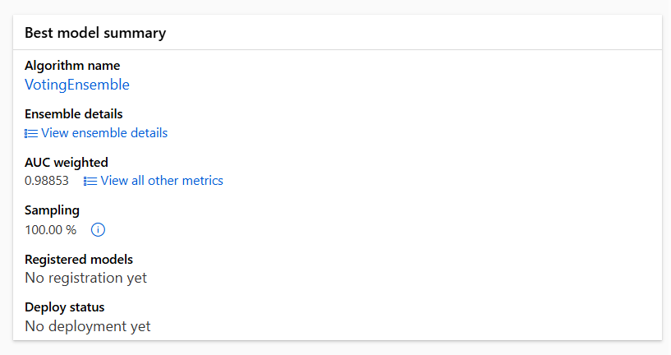
Azure Model Performance
The performance metrics of the Azure model are summarized in Figure (Run Metrics) and include:
Accuracy: 0.9419
AUC (weighted): 0.9885
F1-score (weighted): 0.9417
Balanced Accuracy: 0.9335
Log Loss: 0.1364
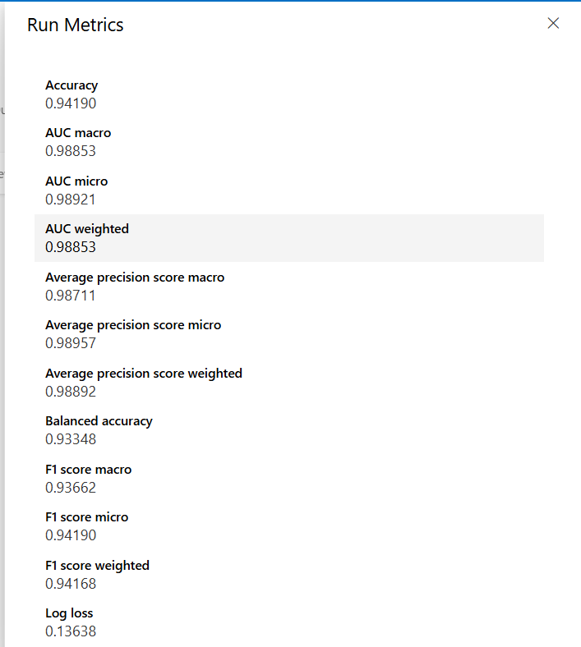
These results demonstrate that the Azure Voting Ensemble model provides high classification accuracy and strong overall performance, particularly in terms of AUC and F1-score, which are important metrics for classification problems with potential class imbalance.
In the Python implementation, a K-Nearest Neighbors (KNN) classifier was trained and evaluated using feature scaling and hyperparameter tuning. The KNN model achieved:
- Accuracy: 0.859
- Precision: 0.8269736842105263
- Recall: 0.9851097178683386
- F1-score: 0.8991416309012875
When compared to the Python-based KNN model, the Azure Voting Ensemble achieved higher accuracy and F1-score, indicating improved predictive performance. This improvement can be attributed to Azure’s use of ensemble learning, which combines multiple models to reduce individual model weaknesses and improve generalization.
The Azure AutoML approach simplifies model selection and optimization by automatically evaluating multiple algorithms and hyperparameter configurations. In contrast, the Python implementation provided greater control and transparency over preprocessing, model selection, and evaluation steps.
While Azure achieved superior performance metrics, the Python implementation offered deeper insight into model behavior and decision-making processes. Both approaches are valid, but they serve different purposes depending on the project requirements.

Why Azure performed better:
Azure’s improvement is mainly due to the ensemble learning approach, where multiple base models contribute to a final decision. Ensembles typically:
- reduce variance compared to single models,
- improve generalization to unseen data,
- and handle complex/non-linear patterns better than simpler models like KNN.
Conclusion: Both environments produced strong results, but the Azure Voting Ensemble achieved higher overall accuracy, F1-score, and AUC, demonstrating superior classification performance, while Python-based modeling remains valuable for interpretability and full control over the workflow.

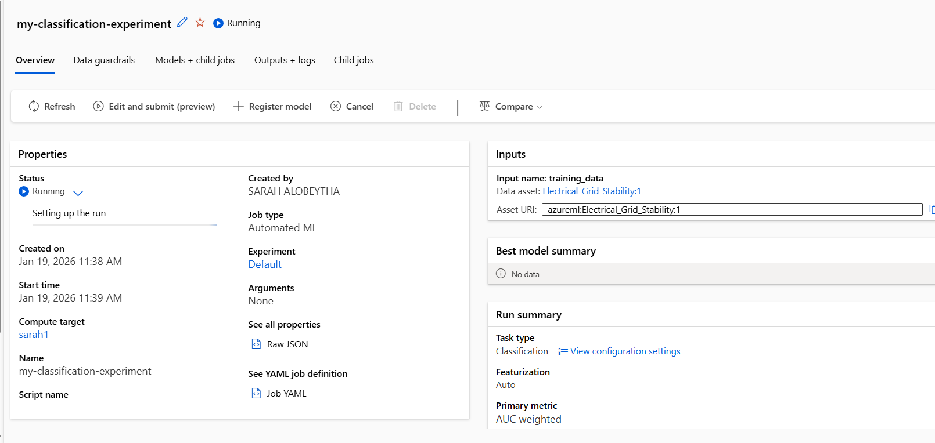
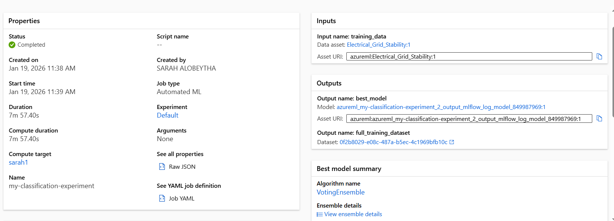
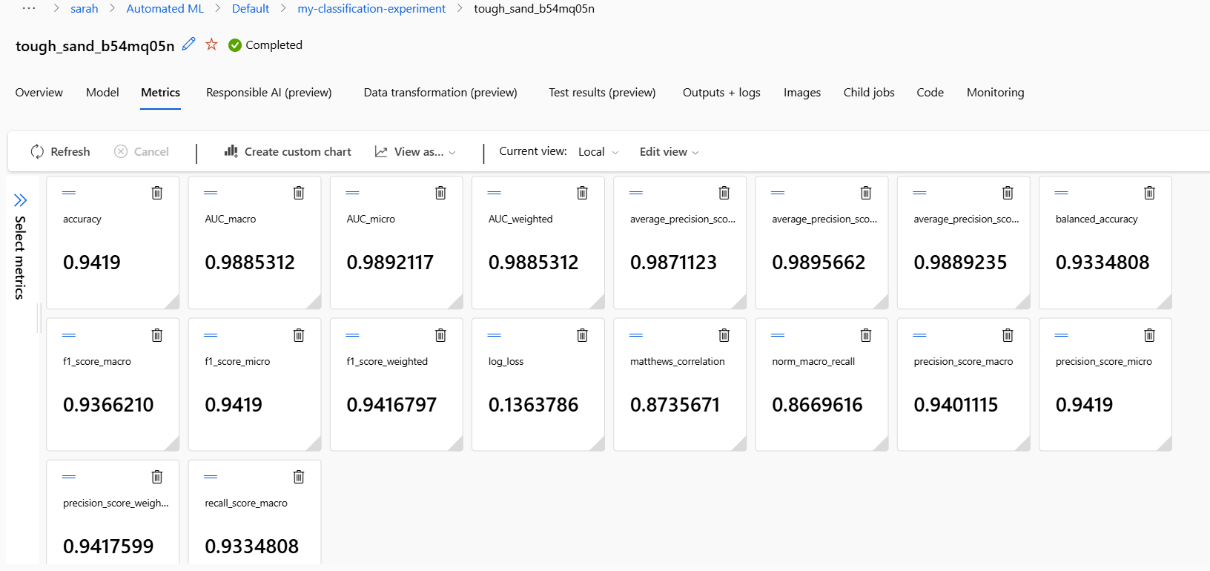
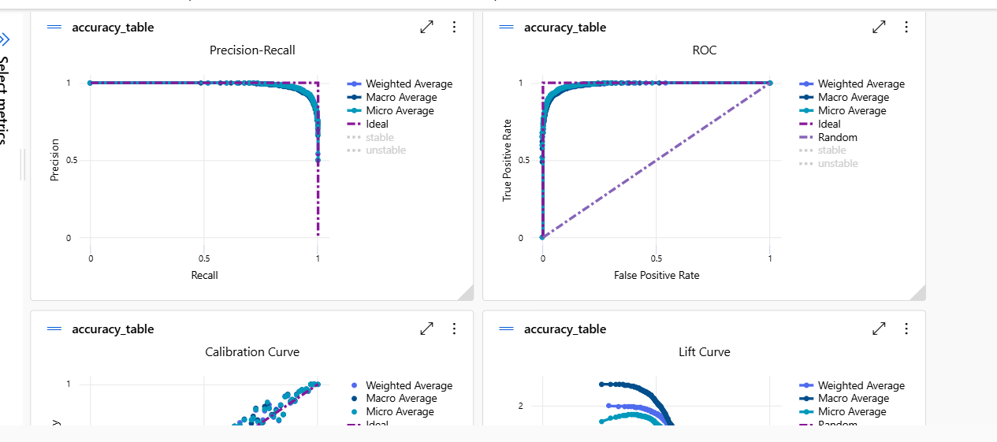
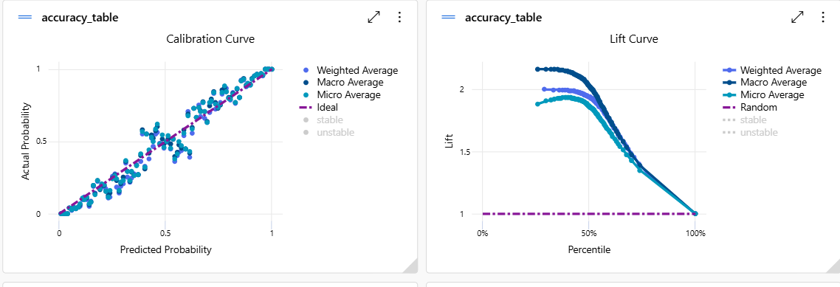
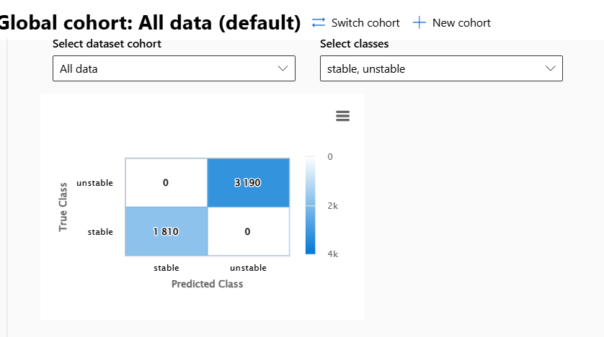
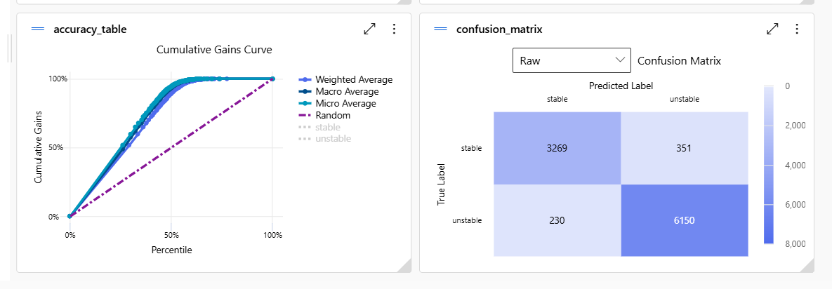

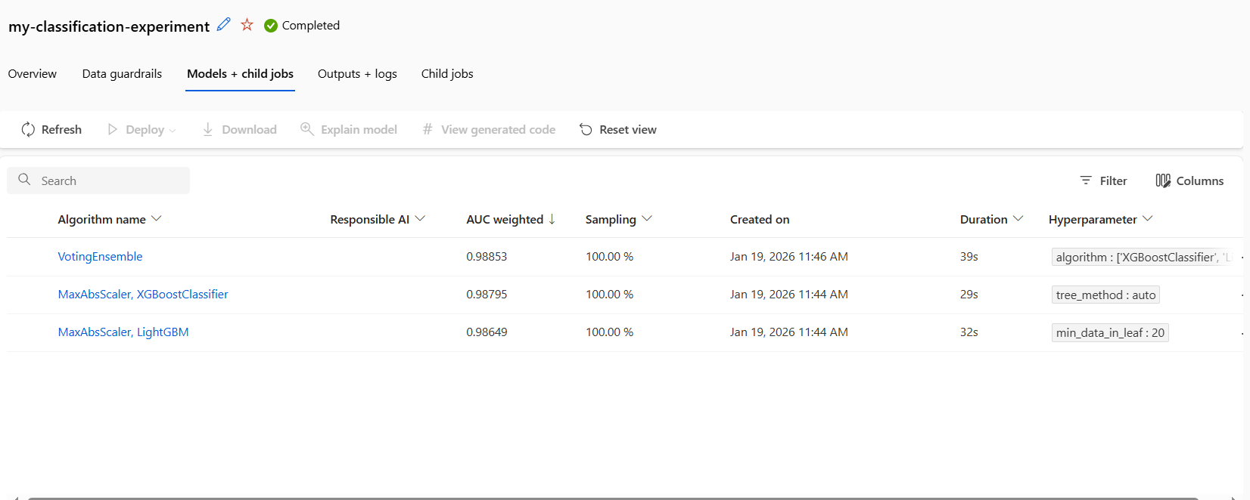
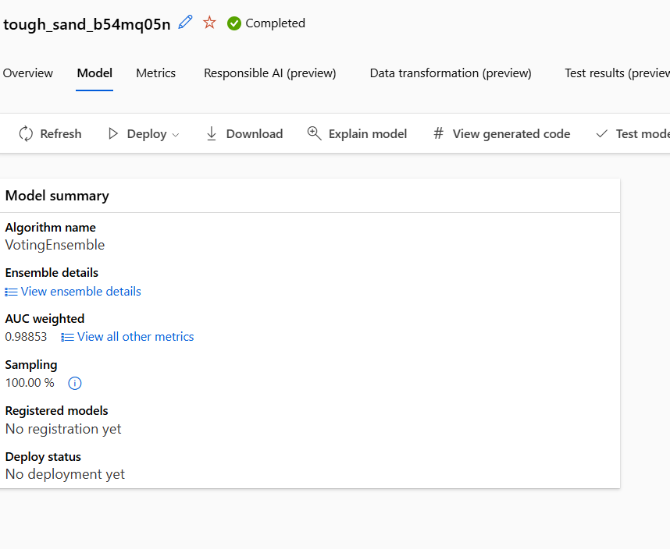


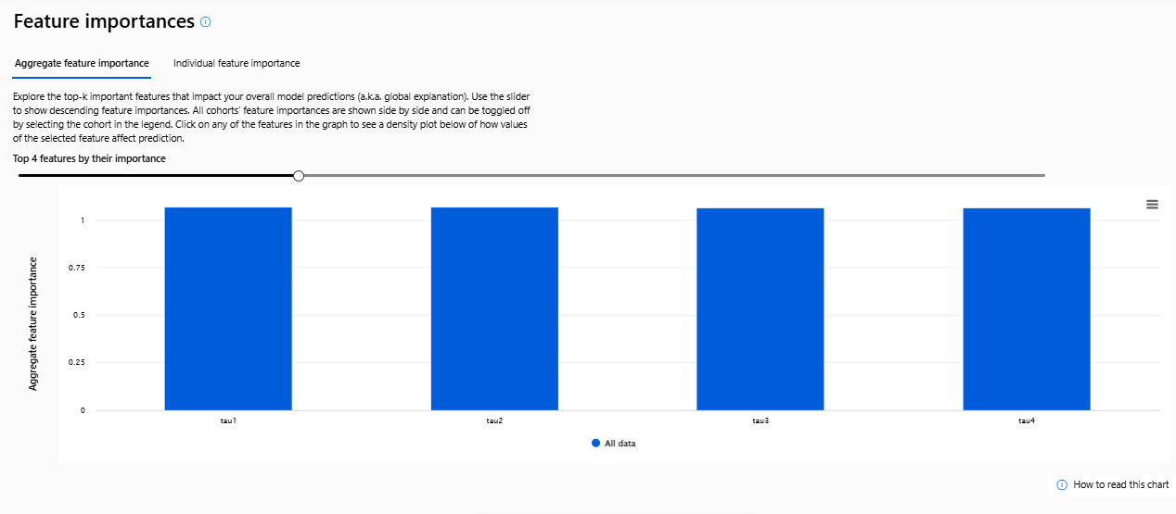

In this project, machine learning models were developed and evaluated using two different environments: a local Python environment and a cloud-based environment using Microsoft Azure Machine Learning.
Performance Comparison
Python environment (manual modeling):
Two models were built based on the nature of the targets:
- Linear Regression for the continuous target stab (regression)
  - MAE = 0.0176, RMSE = 0.0220, R² = 0.644
  - This indicates the model explains about 64% of the variance in stab, with relatively low average error. However, the moderate R² suggests that some non-linear relationships exist that Linear Regression may not capture fully.
- KNN for the categorical target stabf (classification)
  - Accuracy = 0.859, Precision = 0.827, Recall = 0.985, F1 = 0.899
  - The high recall shows the model is very effective at detecting unstable cases, which is valuable in grid stability contexts. However, precision is lower than recall, meaning some stable cases are incorrectly flagged as unstable (false alarms).
Azure environment (AutoML):
Azure AutoML automatically trained and compared multiple algorithms and selected a Voting Ensemble as the best model. The Azure best model achieved:
- Accuracy ≈ 0.9419
- Weighted AUC ≈ 0.9885
- Weighted F1-score ≈ 0.9417
- Balanced Accuracy ≈ 0.9335
- Log Loss ≈ 0.1364
.

Scalability
Python (local scalability limits):
Local Python training depends on the hardware of a single machine (CPU/RAM/storage). As dataset size grows or model complexity increases, limitations appear:
- Training may become slow due to limited compute resources
- Hyperparameter tuning becomes expensive because repeated training runs are required
- Running real-time predictions for many users requires building and maintaining your own server infrastructure
Scaling locally usually means manual steps such as:
- upgrading hardware,
- using GPUs/parallel computing manually,
- or setting up distributed systems (which increases complexity significantly).
Azure (cloud scalability):
Azure provides on-demand scalable compute resources:
- you can train on larger datasets using larger compute clusters,
- parallel experiments can run efficiently (AutoML can evaluate many models in parallel),
- and deployed endpoints can scale to support higher prediction volume.
If the system moves from an academic dataset to a real production setting (more records + more users), Azure can handle this growth without major re-engineering of infrastructure.

Python deployment (manual effort):
Deploying a Python model outside the notebook requires multiple steps and introduces risk of inconsistency:
- Packaging the model (saving model file, e.g., joblib )
- Ensuring the same preprocessing used in training is applied to incoming data
- Building an interface (commonly an API) to serve predictions:
  - real-time (REST endpoint)
  - batch scoring (predict large files)
- Managing dependencies and environment:
  - Python version, libraries, scikit-learn versions
  - containerization (Docker) if needed
- Monitoring:
  - track performance drift, errors, and model updates
This is achievable, but it is time-consuming and depends on manual configuration, which can lead to errors such as “model expects scaled data but received raw values”.
Azure deployment (managed and faster):
Azure improves deployment efficiency because it provides built-in deployment tools:
- Models can be deployed as managed endpoints (real-time prediction service)
- Azure handles:
  - container creation,
  - environment dependencies,
  - hosting and scaling,
  - monitoring and logging
Azure also supports multiple deployment patterns more easily:
- Real-time deployment (instant prediction API)
- Batch deployment (scoring large datasets)
- Scheduled pipelines (automated retraining and redeployment)
Azure reduces deployment time and complexity and improves reliability because deployment steps are standardized.

Moving to Azure offers clear benefits at both technical and organizational levels:
- Higher performance potential
AutoML tests multiple algorithms and often finds stronger models (e.g., ensembles) than a single manually chosen model.
- Improved scalability
Supports larger datasets and higher prediction workloads without hardware limitations.
- Faster and more robust deployment
Built-in deployment services reduce manual setup and ensure reproducibility.
- Reduced operational overhead
Less effort spent on infrastructure, dependency handling, and manual monitoring.
- Better collaboration and governance
Experiments, metrics, models, and runs are stored centrally, making it easier for teams to review and reproduce results.

Local Python modeling provides flexibility and deep control, making it ideal for experimentation and understanding model behavior. However, cloud environments such as Azure provide superior scalability, faster deployment, and often better model performance through automated optimization and ensemble learning. Therefore, moving to Azure is beneficial when the goal is production deployment, scaling larger data, and improving deployment efficiency and maintainability.

- Evaluation of Model Development Decisions
During the development of the machine learning models, several key decisions were made regarding model selection, data handling, hyperparameter tuning, and performance evaluation. Each of these decisions directly influenced the final results and overall effectiveness of the models.

Model Selection
Two different models were used to match the nature of the target variables: Linear Regression for predicting the continuous variable stab, and K-Nearest Neighbors (KNN) for classifying the categorical variable stabf.
The Linear Regression model produced a moderate R² value (0.64), indicating that the model captured a reasonable portion of the variance in the data but was limited in its ability to model more complex relationships. This suggests that the assumption of linearity restricted the model’s performance and prevented it from fully exploiting non-linear patterns present in the dataset.
The KNN classifier achieved high accuracy and recall, showing that it was effective at identifying unstable cases. However, its reliance on distance calculations made it sensitive to feature scaling and potentially less robust to noise. This choice influenced the results by producing strong classification performance but at the cost of higher computational complexity and sensitivity to data distribution.

Data Handling and Preprocessing
The dataset was found to be clean, with no missing values, so no imputation was required. Feature scaling was applied only for the classification task, which significantly improved the performance of the KNN model by ensuring that all features contributed equally to distance calculations.
For the regression task, raw feature values were used. While this simplified the workflow and still produced acceptable results, it may have contributed to instability in predictions when new input values deviated from the original data distribution. This decision likely limited the generalization capability of the regression model.
limitation of the data handling process is that feature engineering was minimal. While the models performed well, additional transformations or interaction features could have further improved predictive accuracy.

Hyperparameter Tuning
Hyperparameter tuning was performed for the KNN model by testing different values of the number of neighbors (k). This process had a clear positive impact on performance, as selecting an optimal k improved accuracy and F1-score compared to default settings.
However, tuning was limited to a single hyperparameter. Expanding tuning to include distance metrics or weighting strategies could further improve model robustness and reduce misclassification errors.
For the Linear Regression model, no hyperparameters were tuned, as the basic implementation was used as a baseline. While this simplified the modeling process, it may have limited the model’s ability to capture more complex patterns in the data.

Performance Evaluation
For the regression model, MAE, RMSE, and R² were used together to capture different aspects of performance. MAE provided a clear and interpretable measure of the average prediction error, showing how far predictions were from the true stab values on average. RMSE placed greater emphasis on larger errors, making it useful for identifying whether the model occasionally produced extreme prediction mistakes. The R² score measured how much of the variance in the target variable was explained by the model. Although the regression model achieved low MAE and RMSE values, the moderate R² value (0.64) revealed that a substantial portion of variability remained unexplained. This highlighted a limitation of the linear model, suggesting that important non-linear relationships were not fully captured.
For the classification model, multiple metrics were necessary because accuracy alone was insufficient due to class imbalance. While the model achieved high accuracy, deeper analysis using precision, recall, F1-score, and the confusion matrix revealed important trade-offs. The very high recall indicated that the model was highly effective at identifying unstable grid conditions, which is critical from a safety and risk perspective. However, the lower precision showed that the model also produced a notable number of false positives, incorrectly classifying some stable cases as unstable.
The confusion matrix made this imbalance visible by explicitly showing the number of false alarms versus missed detections. Without using precision, recall, and the confusion matrix, this trade-off would not have been apparent, and the model might have been incorrectly judged as optimal based solely on accuracy. This evaluation choice directly influenced the understanding of model behavior and highlighted practical implications, such as the potential operational cost of false alarms.
Overall, using a diverse set of evaluation metrics allowed for a more realistic and critical assessment of model performance. It exposed weaknesses related to model assumptions and class imbalance that would have remained hidden if simpler metrics had been used, thereby guiding more informed conclusions and improvement strategies.

Reflection and Possible Improvements
Overall, the decisions made resulted in models that performed well and met the project objectives. However, several improvements could be applied if the activity were repeated. More advanced models such as Random Forest or Gradient Boosting could be explored to capture non-linear relationships more effectively. Consistent preprocessing across all models, including scaling for regression, could improve stability and generalization.
Additionally, cross-validation and more extensive hyperparameter tuning could reduce overfitting and improve reliability. Finally, integrating automated optimization tools or cloud-based training earlier in the process could further enhance performance and scalability.

Conclusion
Overall, the decisions made during model development were appropriate and aligned with the nature of the data and project requirements. Each choice—from model selection to evaluation metrics—had a clear impact on the results. While the final models achieved strong performance, particularly in classification, there remains potential for improvement through more advanced modeling techniques, richer feature engineering, and more systematic optimization)improve system performance ). This highlights that while the development decisions were effective for meeting project requirements, more systematic optimization and advanced modeling would be necessary for real-world deployment.

- Deploying machine learning models for electrical grid stability prediction introduces several challenges and potential disadvantages for both users and organizations. These challenges affect usability, reliability, cost, and long-term sustainability of the deployed system.

Impact on Users
From a user perspective, deployed models can improve decision-making by providing fast and automated predictions about grid stability. This reduces reliance on manual analysis and allows operators to respond quickly to potential instability. However, one major challenge users may face is over-reliance on model predictions. If users trust the system blindly without understanding its limitations, incorrect predictions could lead to poor operational decisions, such as unnecessary shutdowns or failure to respond to real risks.
Another disadvantage is lack of interpretability, especially for non-technical users. Even though the model produces accurate predictions, users may not understand how or why a certain stability decision was made. This can reduce user confidence in the system and make it difficult to justify actions taken based on the model’s output.
Additionally, prediction errors may directly affect users’ trust. False predictions—such as classifying an unstable situation as stable—could pose safety risks, while frequent false alarms could cause unnecessary stress and operational disruptions.

Impact on Organizations
For organizations, deployment improves efficiency by automating analysis, reducing operational costs, and enabling scalability. However, organizations face several challenges after deployment. One key issue is model maintenance. Over time, changes in system behavior or data distribution may cause the model’s performance to degrade, requiring continuous monitoring, retraining, and validation.
Another major challenge is infrastructure and deployment cost, especially when using cloud platforms. While cloud environments provide scalability, they also introduce ongoing costs related to storage, computation, and monitoring. Organizations must carefully balance performance gains against financial sustainability.
There is also a risk of accountability and responsibility. If the deployed model produces incorrect predictions that lead to financial loss or safety incidents, organizations may be held responsible. This raises concerns related to governance, compliance, and decision accountability.

Both users and organizations may face ethical challenges after deployment. Bias in training data can lead to systematic errors that disadvantage certain operational scenarios. Additionally, lack of transparency in automated decisions may reduce trust and increase resistance to adoption.
Operationally, integrating the deployed model with existing systems can be complex and may disrupt current workflows. Employees may require training to effectively use and interpret the system, which adds to organizational overhead.
Conclusion, While deployment of machine learning models offers clear advantages in efficiency and decision support, it also introduces challenges related to trust, interpretability, cost, maintenance, and accountability. A successful deployment strategy must therefore include user training, continuous monitoring, transparent communication of model limitations, and clear organizational policies to mitigate these disadvantages and ensure long-term value.

